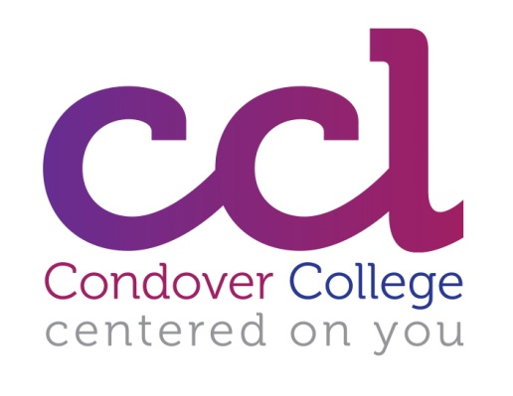
Working for Condover College Ltd
Condover College Ltd is a charitable organisation which provides education provision for young adults aged between 19 and 25 and residential accommodation for adults over the age of 19 years. Residential accommodation is in a number of small houses (3-6 residents) in Shrewsbury and surrounding villages. Our Education Centre is near Shrewsbury.
We were inspected by Ofsted in November 2017 and received a Grade 2, ‘good’ rating.
We currently have 32 students who have a range of profound and multiple learning difficulties, complex needs and/or severe learning difficulties. Our students range from Pre-Entry (Milestones 1-8) up to Entry Level 2

Our students individual learning programmes are focused on one of the two pathways we offer.
The Design for Living Pathway: For students whose main aspirations are to live as independently as possibly, through the development of their communication, personal and social interaction and daily living skills. Some students have a strong sensory focus to their programme to match the way they learn and experience the world.
The Employability Pathway: For students whose main aspirations include getting into voluntary or paid work, as well as developing greater independent living skills. For those who succeed on this pathway there is an option to undertake a supported internship in the final year.

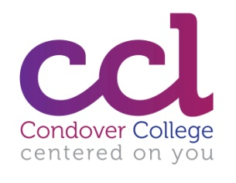
Condover College Ltd - Curriculum
 | Subject
Communication | Communication
 | Social Communication
 | Drama
 | English Speaking Board
 | Makaton Choir
 | Story Telling
 | Subject
Independence | Independent Living
 | Shop & Cook
 | Cooking
 | Home skills
 | Travel Training
 | Eating & Drinking
 | Self Care
 | Mobility
 | Subject
Personal and Social Development | Sensory Experiences
 | Sensory Development
 | Music
 | Gardening
 | Art
 | Crafts
 | Dance
 | Sport & Leisure
 | Subject
Functional Skills | Literacy (focused session)
 | Literacy Embedded
 | Numeracy (focused session)
 | Numeracy Embedded
 | IT (focused Session)
 | IT Embedded
 | Everyday Technology
 | Subject
Work & Community Engagement | Team enterprise
 | Work Skills
 | Work experience
 | Our environment
 | Community Access
 | Citizenship
 | Enrichment
 | Travel Training
 | Gardening
All Personal Tutors are expected to teach a range of subjects from our curriculum, from the Pre-Entry Level up to Entry Level 2, matched with individual tutors’ skills, qualifications, interests and experience.

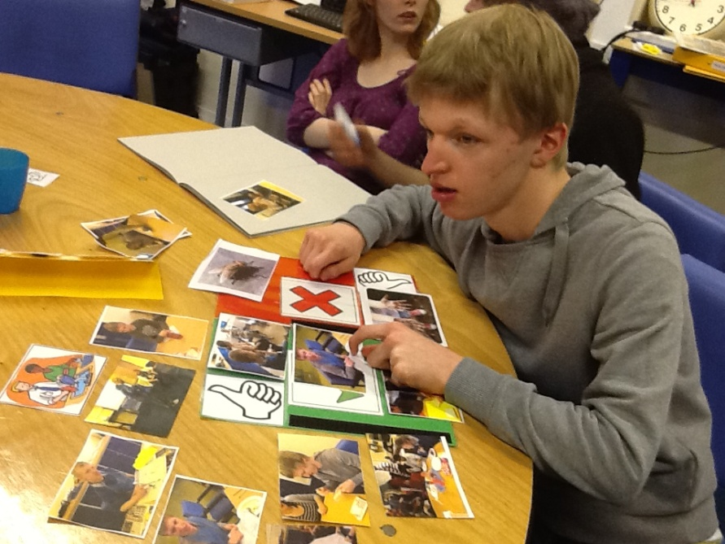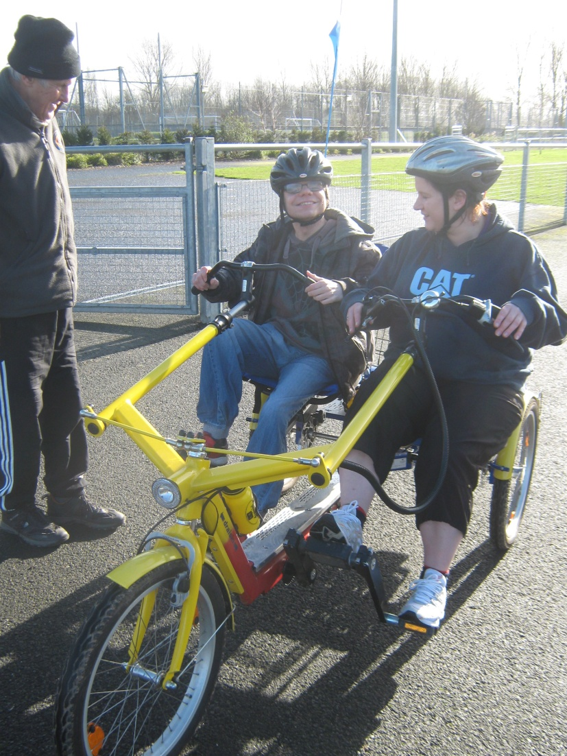
Specialist Teams:
A multi-disciplinary team of personal tutors, associate tutors, learning support staff and in house speech and language therapists and physiotherapists work closely to develop and support the learning of the students.
Expectations and Support:
We have high expectations of both our students and staff and recognise that high quality, well-trained staff are crucial to ensuring the best outcomes for our students. In return we offer a competitive remuneration package (your progression in salary will be dependent upon performance appraisal), comprehensive mentoring and induction and wide ranging opportunities for CPD and training.

